Question 1:

Output for the program to check weather the object are equal or not

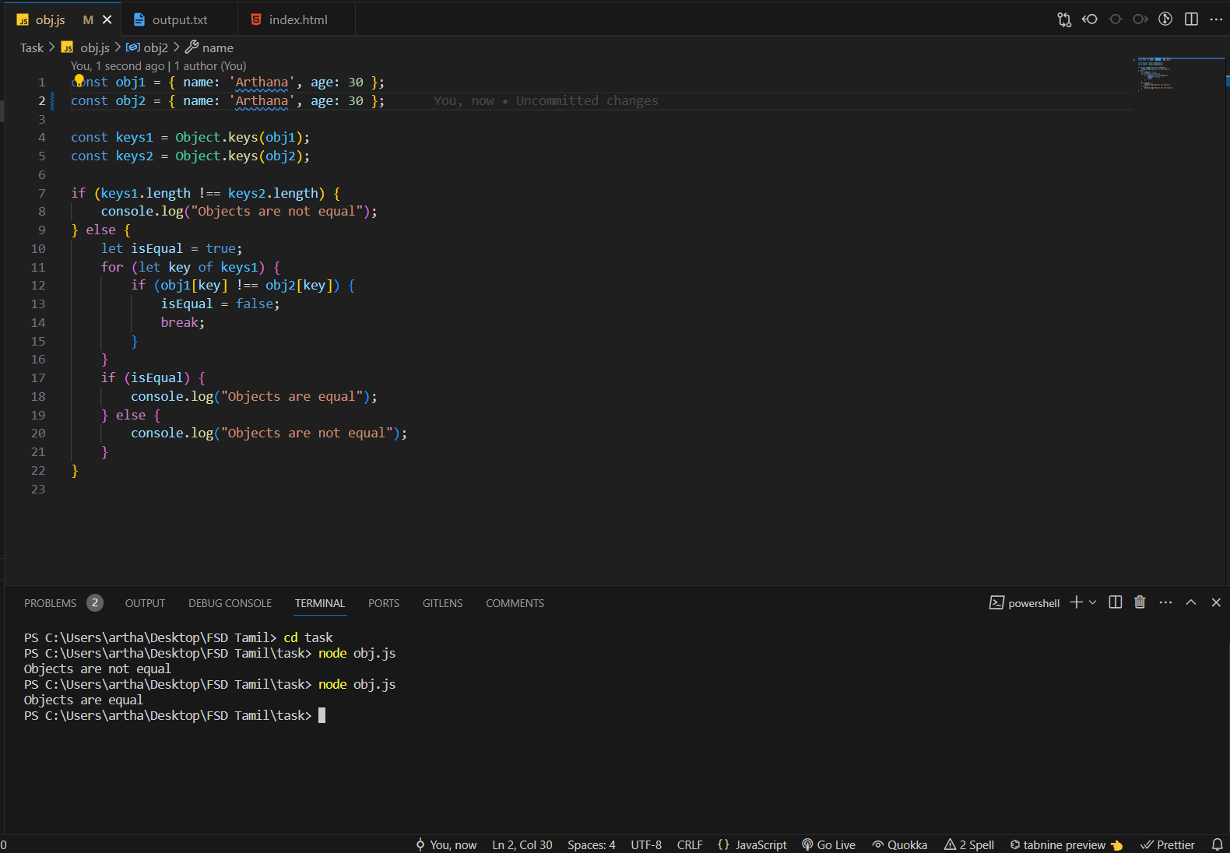

Question 3:

Output for the to print the country name region, subregion and population

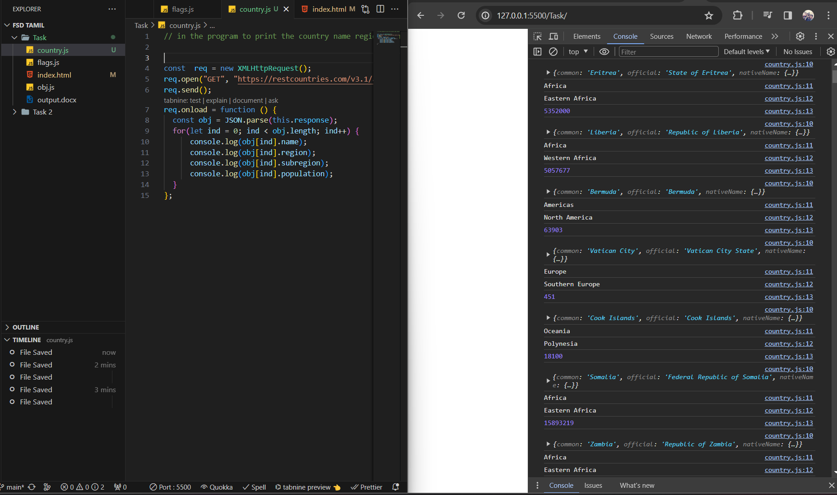

Question 2:

Output for the program to print the flags

